D212: Data Mining II – Task 1
Department of Information Technology, Western Governors University
By Andrew Fagundes
Professor Kesselly Kamara
August 25th, 2025

Table of Contents
Part I 3
A1. 3
A2. 3
Part II 4
B1. 4
B2. 5
B3. 5
Part III 6
C1. 6
C2. 6
C3. 6
C4. 9
Part IV 10
D1. 10
D2. 11
Part V 14
E1. 14
E2. 14
E3. 14
E4. 15
Part VI 15
References (No third-party code references used) 16

Part I

A1.
Can patients be segmented based on medical spending and health habits using k-means? This question helps hospitals and healthcare providers identify high-risk patients needing frequent medical attention. Analyzing patient factors optimizes healthcare costs by tailoring insurance, intervention, and wellness plans for improved health outcomes.

A2.
K-means clustering is an unsupervised machine learning technique that partitions data into k clusters based on feature similarity (https://uc-r.github.io/kmeans_clustering). It minimizes intra-cluster variance and maximizes inter-cluster distance when applied to continuous variables (Datacamp.com).
K-means analysis clusters patients based on financial and medical behavior, identifying distinct groups based on healthcare spending and visit patterns. This improves resource allocation and personalized care. It helps understand healthcare utilization, optimize resources, and develop targeted intervention programs. The data set has multiple continuous variables suitable for clustering without complex feature engineering.

Part II

B1.
K-means clustering groups patients based on similar healthcare spending and visit behaviors. It analyzes data by selecting relevant continuous variables for preprocessing. Standardized variables ensure equal weight (Datacamp.com). K-means clustering partitions data into k groups/clusters, where k represents the number of groups/clusters, where objects in the same cluster are similar and those in different clusters are dissimilar (https://uc-r.github.io/kmeans_clustering). Each cluster is represented by its center (centroid), which is the mean of points assigned to the cluster (https://uc-r.github.io/kmeans_clustering). K-means aims to minimize the total intra-cluster variation (https://uc-r.github.io/kmeans_clustering). This is done through the following steps (https://uc-r.github.io/kmeans_clustering): Specify K, select k random objects as initial cluster centers, assign observations to their closest centroid based on Euclidean distance, update cluster centroid as new mean values of cluster data points, and iteratively minimize total within-sum-of-squares until assignments stabilize or maximum iterations reached.
The elbow method determines the optimal number of clusters based on inertia (Datacamp.com). A K-Means algorithm assigns patients to clusters based on feature similarities. The model analyzes the clusters, splitting them into high-, moderate-, and low-cost groups. This analysis segments patients into 3-5 groups based on medical expenses and visits, enabling targeted interventions and optimized resource allocation.

B2.
K-Means clustering assumes spherical, equally sized clusters in feature space (Datacamp.com). Real-world data may deviate, so preprocessing (e.g., scaling, outlier removal) can improve results.

B3.
Python packages and libraries chosen for this analysis:
- Pandas is used for loading, cleaning, and structuring the data set
- Numpy is used for efficient numerical computation for mathematical operations on arrays
- Matplotlib.pyplot is used for data visualization, creating elbow plots and scatter plots for insights
- Sklearn.cluster.KMeans is used for the K-Means clustering algorithm implementation in the clustering model
- Sklearn.preprocessing.StandardScaler is used to normalize data to ensure equal weight for all features
- Sklearn.metrics.silhouette_score is used to evaluate clusters and measure their separation
- Seaborn is used for data visualizations

Part III

C1.
To ensure K-Means clustering is unbiased, standardize all selected continuous variables. StandardScaler() transforms values to have a mean of 0 and a standard deviation of 1, preventing features with larger numeric values from dominating the clustering process (Datacamp.com).

C2.
Continuous variables selected for analysis:
- TotalCharge (continuous)
- Additional_charges (continuous)
- Doc_visits (continuous)
- Income (continuous)
- VitD_levels (continuous)
- Full_meals_eaten (continuous)
K-Means only works with continuous data, so categorical variables won’t be clustered, but they can help interpret results after analysis.

C3.
To ensure the medical dataset is clean and ready for analysis, several steps must be followed.
Load data into the notebook for analysis. A read_csv function was used for this.
After loading the dataset into the workbook, evaluate and clean its data structure. Functions allow you to examine the data structure, identifying numerical, categorical, and text columns. Removing null values, missing data, and outliers is crucial for K-Means analysis, as it helps identify features that may need conversion or removal.
First, a .head() and .info() were called to display the data structure’s overview, including datatypes and field names. 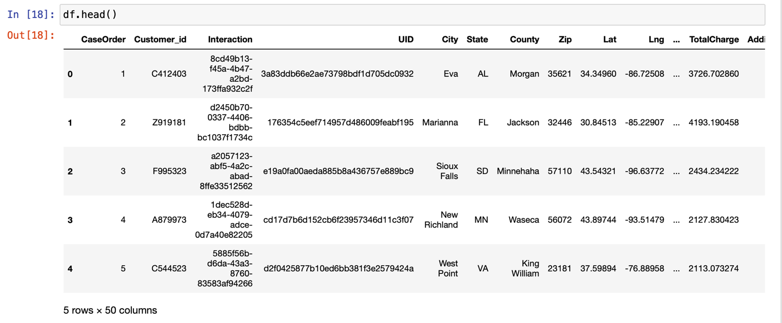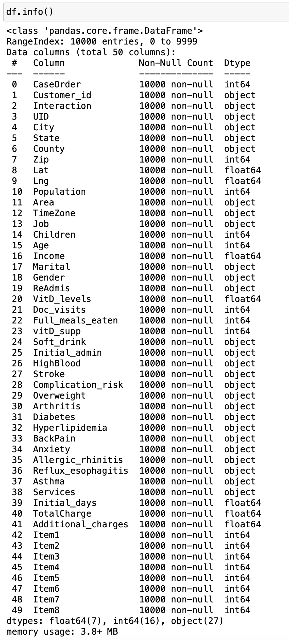
Use `isnull()` to check for null values and `.describe()` to identify outliers. The output showed no nulls or outliers. 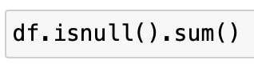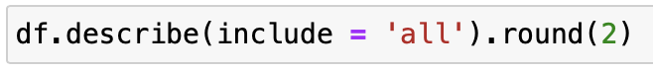
After cleaning the dataset for inconsistencies, we select features for analysis. We input an initial list of adequate continuous variables into a ‘selected_df’ data frame to describe and classify them.
Standardize the selected variables by transforming continuous variables to have a Mean of 0 and a Standard Deviation of 1. This is crucial for K-Means, which uses distances between points to measure similarity. Standardization ensures equal contribution from each variable, leading to more meaningful cluster formation. Apply StandardScaler and fit_transform on the selected variables to standardize them. Store the results in a data frame called ‘df_scaled’ for analysis.
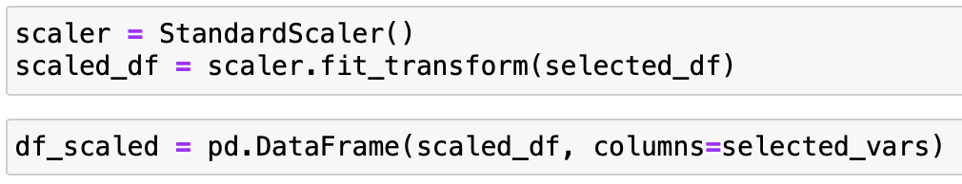

C4.
The prepared dataset in CSV format, submitted for assessment, is in ‘prepared_medical_data.csv’.

Part IV

D1.
The optimal number of clusters is identified using the Elbow Method. It plots the inertia (within-cluster sum of squared distances) for various k values (Datacamp.com). The Elbow Curve is a scatter plot where the inertia curve bends significantly, suggesting the best k for clustering. Key points include the Elbow Point and the scatter plot itself.
The inertia (sum of squared distances) decreases sharply from k = 1 to k = 4, indicating significant clustering improvement. After k = 4, the rate slows, forming an ‘elbow’ at k = 4 or 5. Beyond k = 5, the reduction is gradual, meaning additional clusters add less to segmentation.
Try both k = 4 and k = 5 and compare their silhouette scores to determine the best segmentation, as the ‘elbow’ appears most prominent at these values.
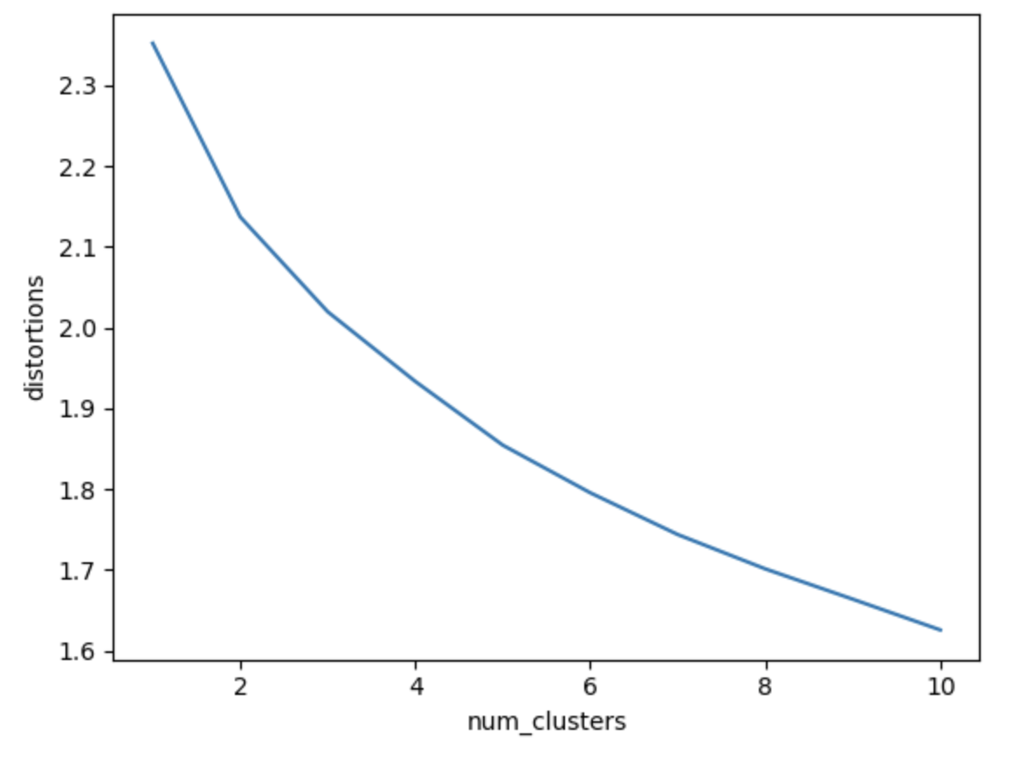

D2.
Before applying K-Means, determine the optimal number of clusters (k) using the Elbow Method. Plot the inertia values and display the Elbow Curve as a scatter plot.
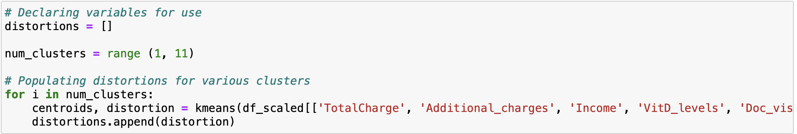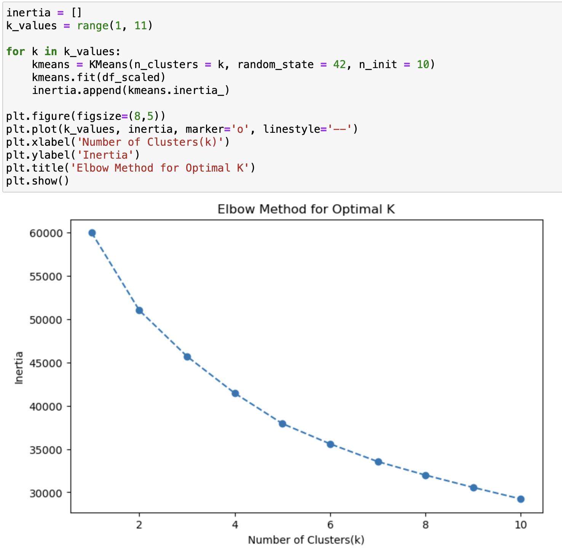
Repeat the steps for k = 4 and 5 to identify the better-defined clusters. For k = 4, once the optimal k is identified, fit K-Means on df_scaled. This applies K-Means with the optimal number of clusters and assigns each record to a cluster based on feature similarity.
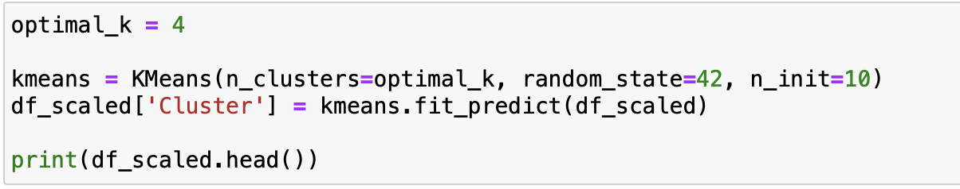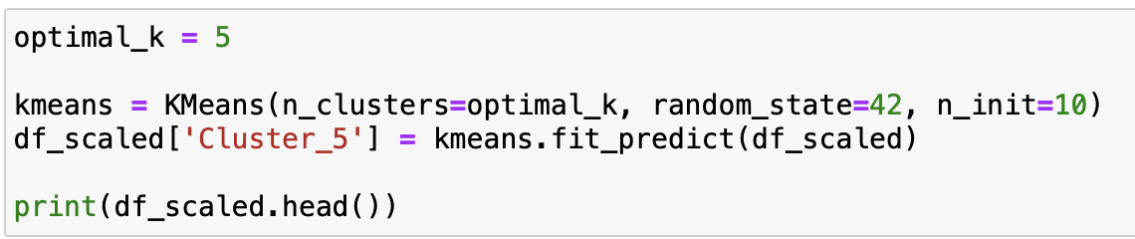
To measure cluster separation, the silhouette score is calculated. It evaluates cluster quality, with a score closer to 1 indicating well-defined clusters. The Silhouette score for k = 4 was .17, indicating poorly defined clusters.
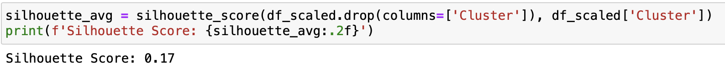
Fit KMeans on df_scaled with the optimal k once identified. This will assign each record to a cluster based on feature similarity.
To measure cluster separation, the silhouette score is calculated. It evaluates cluster quality, with a score closer to 1 indicating well-defined clusters. The Silhouette score for k = 5 was .22, indicating poorly defined clusters.

Part V

E1.
The Silhouette Score measures the quality of clustering based on how well-separated the clusters are.
- Silhouette Score for k = 4 is 0.17.
- Silhouette Score for k = 5 is 0.23.
These scores indicate weak clustering, with clusters not well-separated and some points near decision boundaries. The low scores suggest significant cluster overlap. Increasing clusters beyond k=5 doesn’t improve separation, suggesting the dataset lacks distinct groupings or K-Means may not be optimal.

E2.
The dataset forms weak clusters, indicating that patient spending and healthcare usage patterns are not distinct. These clusters likely represent slight variations in medical spending and behavior, rather than entirely different patient groups. Implications arise for various parties. Hospital and insurance providers may face challenges in clear-cut pricing and policy decisions due to weak segmentation. However, wellness programs can still use these clusters to group patients into general spending categories for targeted healthcare programs. Additional categorical variables (e.g., medical conditions, geographic location) may refine the clusters further.

E3.
Only continuous variables can be used for clustering, limiting the analysis to key healthcare factors like medical conditions, lifestyle choices, and insurance type, which are categorical. K-Means assumes spherical clusters, but real-world patient behavior may not fit this shape, leading to poor separation. Alternative methods like Hierarchical Clustering might better capture non-spherical patterns in healthcare data.

E4.
Based on weak clustering results, the organization should expand feature selection, try alternative clustering methods, use clusters for broad grouping, or further validate with business insights. Expanding feature selection to include categorical variables (e.g., medical history, chronic diseases, insurance plans) using one-hot encoding allows testing new features and refining segmentation. Alternative clustering methods may reveal better patient spending behavior relationships or improve the model for real-world medical data. Using clusters for broad grouping can identify patient behavior trends and develop generalized intervention strategies. Further validating with business insights allows cross-checking cluster patterns with hospital administrators or insurers to refine analysis before strategic decisions. Incorporating categorical data and alternative clustering techniques enhances analysis, leading to better patient segmentation and improved healthcare decision-making.

Part VI
The video recording includes a vocal presentation of the dashboard and a discussion of its charts. The video recording can be found inside the Panopto drop box titled “Data Mining II – OFM4”. Panopto video link: https://wgu.hosted.panopto.com/Panopto/Pages/Viewer.aspx?id=d1a2e2df-d3fe-4818-a542-b34101129e61.

References (No third-party code references used)
DataCamp.com. (March 10, 2023). Introduction to k-means Clustering with scikit-learn in Python. https://www.datacamp.com/tutorial/k-means-clustering-python.
UC Business Analytics R Programming Guide. K-means Cluster Analysis. https://uc-r.github.io/kmeans_clustering.

